Paper Title

(5)Noisy ECG Signal Analysis for Automatic

Peak Detection

1. **Preprocessing: Filtering & Segmentation**

the ECG signal is filtered by adopting a band-pass Finite Impulse Response (FIR) filter .

Methods:-

1. Adopted Techniques.

1.1. Hilbert Transform.

1.2. Wavelet Transform.

1. **Feature Extraction**

detection of R peaks.

1. **Classification & Classifier**
2. **Accuracy**

The sensitivity (Se) is defined as the probability of detecting a R point

when a R point actually exists; the positive prediction (+P) represents the probability of detecting a R point among the detected ECG peaks.

The obtained performance confirms that the algorithm is immune to noise up to SNR values equal to 6dB. In fact, for SNR = 6 dB, results with

minimum interferences from noise and artifacts have been obtained, since Se e +P achieves values of 98.13% and 96.91%, respectively.

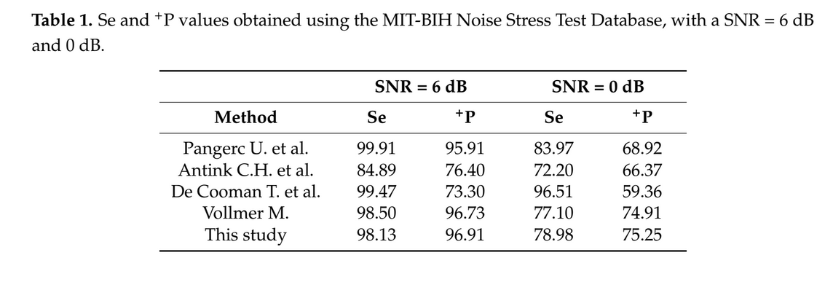

1. **Two Leads or One Lead ? In case of two leads .. how classification of two leads is merged to have final decision ?**
2. **Classes**